 | Find the Best TP-LINK PCI Wireless Adapter For You
 | 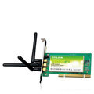  TL-WN951N Wireless-N PCI Adapter | 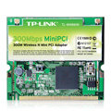  TL-WN861N Wireless-N Mini PCI Adapter | 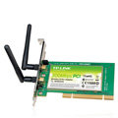  TL-WN851N Wireless-N PCI Adapter | 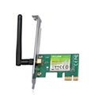  TL-WN781ND 150M Wireless-N PCIE Adapter | 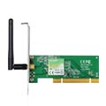  TL-WN751ND Wireless-N PCI Adapter
SPEED | Up to 300Mbps  Wireless-N | Up to 300Mbps  Wireless-N | Up to 300Mbps  Wireless-N | Up to 150Mbps  Wireless-N | Up to 150Mbps  Wireless-N
CONNECTION TYPE | 32-Bit PCI | 32-Bit Mini PCI | 32-Bit PCI | PCI Express | 32-Bit PCI
ANTENNAS | 3 Detachable Omnidirectional | On-Board | 2 Detachable Omnidirectional | Detachable Omnidirectional | Detachable Omnidirectional
MIMO TECHNOLOGY
QSS ONE TOUCH WIRELESS SECURITY
INTERNET PHONE CALLS | Best | Better | Better | Good | Better / Good
VIDEO STREAMING | Best | Better | Better | Good | Better / Good
ONLINE GAMING | Best | Better | Better | Good | Better / Good

